Steps：

1. Make
2. ./a.out addresses.txt

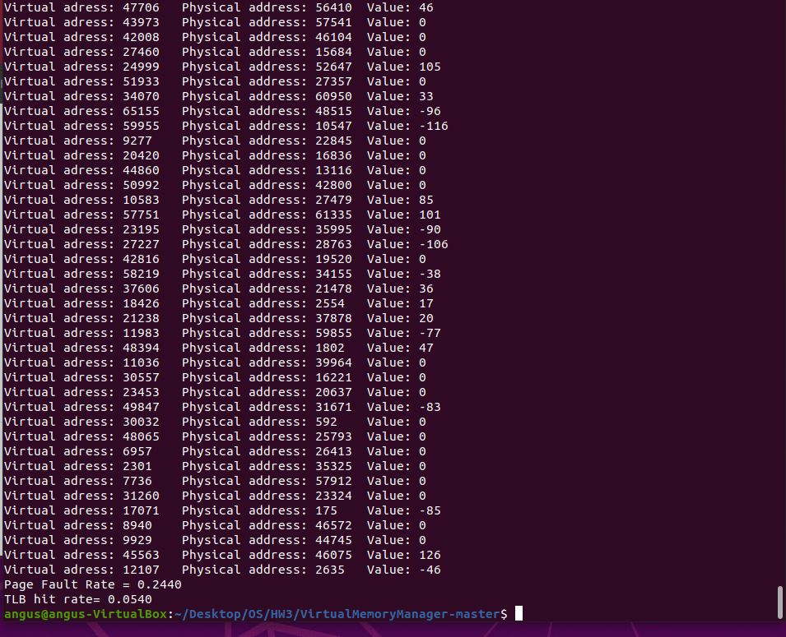

Source code：

#include <stdio.h>

#include <stdlib.h>

#include <string.h>

#include <stdbool.h>

const int PAGE_TABLE_SIZE = 256;

const int BUFFER_SIZE = 256;

const int PHYS_MEM_SIZE = 256;

const int TLB_SIZE = 16;

struct TLB {

unsigned char TLBpage[16];

unsigned char TLBframe[16];

int ind;

};

int readFromDisk (int pageNum, char *PM, int* OF){

char buffer[BUFFER_SIZE];

memset(buffer, 0, sizeof(buffer));

FILE *BS;

BS = fopen("BACKING_STORE.bin", "rb");

if (BS == NULL){

printf("File failed to open\n");

exit(0);

}

// printf("offset in fseek: %d\n", pageNum*PHYS_MEM_SIZE);

if (fseek(BS, pageNum * PHYS_MEM_SIZE, SEEK_SET)!=0)

printf("error in fseek\n");

if (fread(buffer, sizeof(char), PHYS_MEM_SIZE, BS)==0)

printf("error in fread\n");

int i = 0;

for(i; i < PHYS_MEM_SIZE; i++){

*((PM+(*OF)*PHYS_MEM_SIZE)+i) = buffer[i];

/* printf("buffer[%d]=%d\n",i+pageNum*256, buffer[i]);*/

}

(*OF)++;

return (*OF)-1;

// printf("&d\n ", *((PM+i*n)+j));

// i = current row row number, n = elements per row, j = colum num

}

int findPage(int logicalAddr, char* PT, struct TLB *tlb, char* PM, int* OF, int* pageFaults, int* TLBhits){

unsigned char mask = 0xFF;

unsigned char offset;

unsigned char pageNum;

bool TLBhit = false;

int frame = 0;

int value;

int newFrame = 0;

printf("Virtual adress: %d\t", logicalAddr);

pageNum = (logicalAddr >> 8) & mask;

// printf("%X\t", pageNum);

offset = logicalAddr & mask;

// printf("%X\t", offset);

//Check if in TLB

int i = 0;

for (i; i < TLB_SIZE; i++){

if(tlb->TLBpage[i] == pageNum){

frame = tlb->TLBframe[i];

TLBhit = true;

(*TLBhits)++;

// printf("TLBhit\t\t");

}

}

//Check if in PageTable

if (TLBhit == false){

if (PT[pageNum] != -1){

// printf("Pagehit\t\t");

}

//if not in either read from disk

else{

// printf("pageFault\t");

newFrame = readFromDisk(pageNum, PM, OF);

PT[pageNum] = newFrame;

(*pageFaults)++;

// tlb->TLBpage[tlb->ind] = pageNum;

// tlb->TLBframe[tlb->ind] = newFrame;

// tlb->ind = (tlb->ind + 1)%TLB_SIZE;

}

frame = PT[pageNum];

tlb->TLBpage[tlb->ind] = pageNum;

tlb->TLBframe[tlb->ind] = PT[pageNum];

tlb->ind = (tlb->ind + 1)%TLB_SIZE;

}

int index = ((unsigned char)frame*PHYS_MEM_SIZE)+offset;

value = *(PM+index);

printf("Physical address: %d\t Value: %d\n",index, value);

return 0;

}

int main (int argc, char* argv[]){

int val;

FILE *fd;

int openFrame = 0;

int pageFaults = 0;

int TLBhits = 0;

int inputCount = 0;

float pageFaultRate;

float TLBHitRate;

unsigned char PageTable[PAGE_TABLE_SIZE];

memset(PageTable, -1, sizeof(PageTable));

struct TLB tlb;

memset(tlb.TLBpage, -1, sizeof(tlb.TLBpage));

memset(tlb.TLBframe, -1, sizeof(tlb.TLBframe));

tlb.ind = 0;

char PhyMem[PHYS_MEM_SIZE][PHYS_MEM_SIZE];

if (argc < 2){

printf("Not enough arguments\nProgram Exiting\n");

exit(0);

}

fd = fopen(argv[1], "r");

if (fd == NULL){

printf("File failed to open\n");

exit(0);

}

//printf("Value\tPageNum\tOffset\n ");

while (fscanf(fd, "%d", &val)==1){

// printf("%d\t", val);

findPage(val, PageTable, &tlb, (char*)PhyMem, &openFrame, &pageFaults, &TLBhits);

inputCount++;

}

// readFromDisk(0, (char*)PhyMem, &openFrame);

/* int i = 0;

for (i; i < PHYS_MEM_SIZE; i++)

printf("PhyMem[%d]=%d\n",i, PhyMem[0][i]);

*/

pageFaultRate = (float)pageFaults / (float)inputCount;

TLBHitRate = (float)TLBhits / (float)inputCount;

printf("Page Fault Rate = %.4f\nTLB hit rate= %.4f\n",pageFaultRate, TLBHitRate);

close(fd);

return 0;

}